Questions Summary & Analysis
Database System - 2025
Revision 03

Contents
How to? 1
Question Sets considered 1
Shobuj Sir (x3) 2
Chapter 1 (Introduction) 2
Chapter 2 (Introduction to the Relational Model) 2
Chapter 3 (Introduction to SQL) 2
Chapter 4 (Intermediate SQL) 3
Chapter 5 (Advanced SQL) 3
Chapter 9 (Application Development) 3
Chapter 17 (Transactions) 3
Murad Sir (x3) 4
Chapter 6 4
Oracle database 4
Chapter 5 (The Basic Parts of Speech in SQL) 4
Chapter 18 (Basic Oracle Security) 4
Chapter 30 (Triggers) 4

How to?
Bold texts were included in previous years questions.
* mark represents repentance amount.
Strike-through refers to out of syllabus.
Highlighted texts are something I didn’t find in materials, so help me to find it :)

Question Sets considered
- Session 20-21
- Session 19-20
- Session 18-19
- Mid-questions (secondary)

By no means, this is any sorts of suggestions. Just a quick overview!
Nothing more, nothing less :)
And yah, can be inaccurate! Feel free to criticize.

Shobuj Sir (x3)

Chapter 1 (Introduction)
- Various properties of DBMS
- Five responsibility of data management system
- Concurrency
- Database approach vs file approach *
- Why DB uses declarative query language instead of providing lib of procedure language
- SQL vs MySQL vs SQL Server *
- Password security in database
- Purposes of database system
- Levels of abstraction in database systems
- DBMS vs RDBMS
- NoSQL
- 3V of big data (volume, variety, velocity) – check slide!

Chapter 2 (Introduction to the Relational Model)
- Primary vs cadidate vs foreign vs super key *
- List 2 reasons why NULL values might be introduced into a database
- CHAR vs VARCHAR
- Schema diagram of university
- Relational Algebra
  - select
  - project
  - Cartesian-product
  - set

Chapter 3 (Introduction to SQL)
- Queries condition check
- Like operator with lower() function to use case-insensitive matching
- WHERE vs HAVING clause
- DBMS Queries
  - Select
  - Where
  - Join
  - Group by
  - Not in/ exists
  - Aggregate functions
  - Insertion

Chapter 4 (Intermediate SQL)
- Violation of foreign key while inserting or deleting
- SQL constrains and integrity constrains **
- DBMS Queries
  - Natural Join
  - Inner, left, right and full outer join
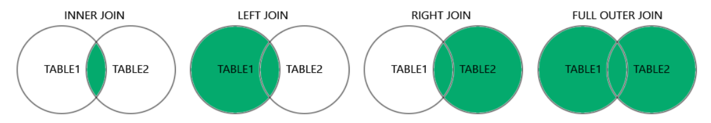

Chapter 5 (Advanced SQL)
No data!

Chapter 9 (Application Development)
- 3 schema architecture
- SQL injection

Chapter 17 (Transactions)
- ACID property *
- Transition states
- Transaction property
- Transaction schedule
- Serializable and conflict serializable
- “A schedule is called conflict serializability if after swapping of non-conflicting operations, it can transform into a serial schedule”
- Read committed and repeatable read isolation
- Snapshot isolation

Murad Sir (x3)

Chapter 6
- ER diagram of Batch management system
- ER diagram for the University Management system
- Different types of keys *
- Normalization **
- Various types of attribute with example **
- Total and partial participation
- Weak entity set
- “The Cardinality ratio of a relationship can affect the placement of relationship attributes”

Oracle database

Chapter 5 (The Basic Parts of Speech in SQL)
- Select, where

Chapter 18 (Basic Oracle Security)
- Expired vs locked account
- PASSWORD_REUSE_TIME vs PASSWORD_REUSE_MAX – mutually exclusive

Chapter 30 (Triggers)
- Statement level trigger – BEFORE DELETE
- Why and which cases triggers can be used
- System privilege required to create a trigger on a table

